BAUANG AGRICULTURAL TRADE CENTER CENTRALIZED
DISTRIBUTION AND ALLOCATION
MANAGEMENT SYSTEM

A Project Documentation
Presented to
the Faculty of Information Technology
Saint Louis College
City of San Fernando, La Union

In Partial Fulfillment
of the Requirements for the Course
IT 121 – Advanced Database Systems

by:
FIRSTNAME MI. LASTNAME
FIRSTNAME MI. LASTNAME
FIRSTNAME MI. LASTNAME
FIRSTNAME MI. LASTNAME
FIRSTNAME MI. LASTNAME

Project Description

The Bauang Agricultural Trade Center (BATC) Centralized Distribution and Allocation Management System is a role-based web application designed to digitize and streamline the agricultural aid distribution process of the Bauang Local Government Unit (LGU) in La Union, Philippines. The system operates across three distinct user roles — Administrator, Staff, and Client (Farmer) — each provided with a dedicated interface and set of responsibilities aligned to their function in the overall distribution workflow.

The Administrator holds the highest level of access in the system. Upon logging in, the Administrator can manage all user accounts, including creating, updating, and archiving Staff and Client accounts. The Administrator oversees the full lifecycle of agricultural programs by defining program codes, coverage dates, target barangays, and eligibility criteria such as livelihood type, farm area, household size, and special classifications (4Ps beneficiary, PWD, or Indigenous People). The Administrator also manages the system inventory by adding inventory items organized by category and unit, recording stock batches with lot numbers and expiry dates, and monitoring stock levels against defined thresholds. Furthermore, the Administrator reviews and approves or rejects farmer applications, manages distribution scheduling and status updates, generates and downloads reports in CSV format, and broadcasts targeted announcements to specific roles or barangays. All significant system actions are captured in an audit log, which the Administrator can access for accountability and traceability purposes.

The Staff user functions as a field encoder and application processor within the system. Staff members are responsible for registering farmer profiles following the RSBSA (Registry System for Basic Sectors in Agriculture) format, capturing personal information such as name, date of birth, civil status, educational attainment, livelihood type, farm area, household size, barangay address, and special category classifications. Staff can review pending farmer applications, evaluate eligibility based on program-defined criteria, and update application statuses to Under Review, Approved, or Rejected with accompanying remarks. Staff also manage distribution records by scheduling aid releases and updating delivery statuses, including transitions to Scheduled, Delayed, Rescheduled, Delivered, Out of Stock, or Unavailable. Additionally, Staff can process stock movements by recording received and released inventory batches, and can respond to farmer-submitted feedback through the feedback management panel.

The Client user represents the registered farmer who accesses the system through a simplified, mobile-friendly portal. Upon logging in, the Client can view their personal farmer profile containing their RSBSA details, barangay information, and verification status. Clients can browse the list of available agricultural programs and determine their eligibility based on the program criteria. They can monitor the status of their submitted applications, tracking whether their request is under review, approved, rejected, or fulfilled. Clients can also view their distribution records to check the scheduled release dates and current delivery status of their agricultural inputs. After receiving a distribution, Clients may submit feedback by providing a star rating (1–5), selecting an issue type (General, Damaged, Expired, Wrong Quantity, or Wrong Item), and adding descriptive comments. Clients can also view announcements that are targeted to their barangay or farmer segment (4Ps, PWD, or Indigenous People).

Use Case Diagram

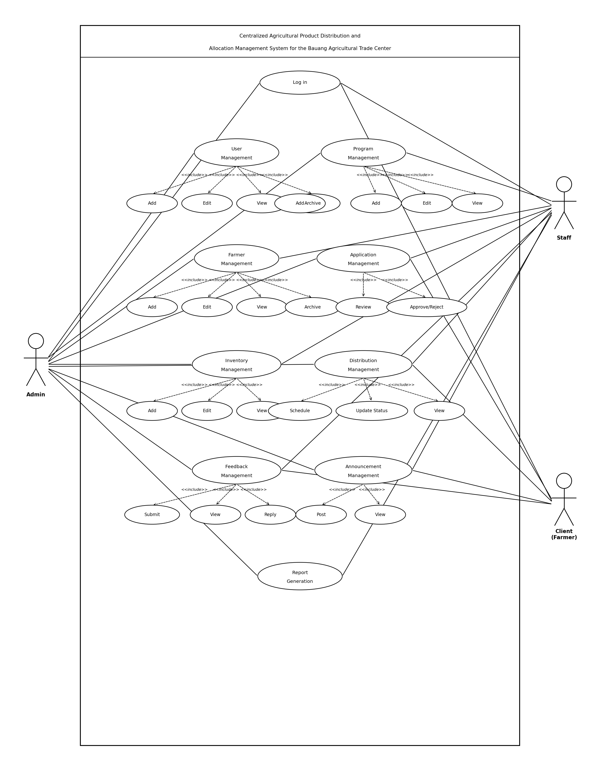

Entity Relationship Diagram

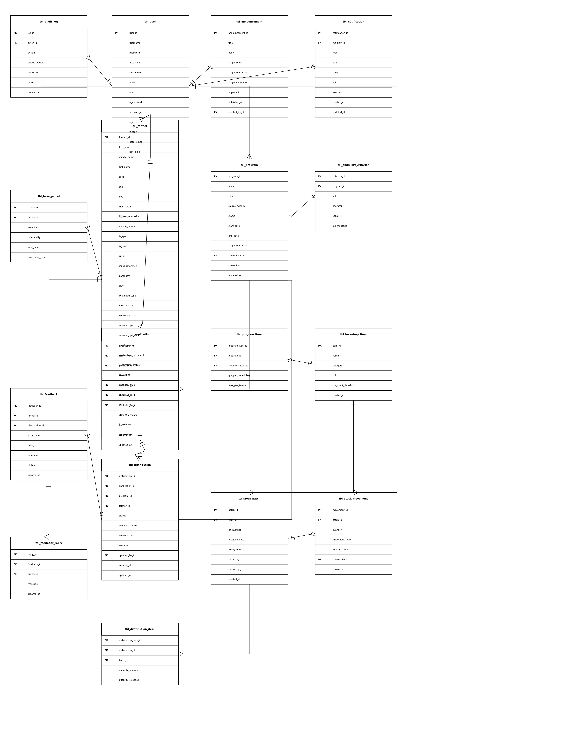

Relational Database Schema

tbl_announcement {announcement_id, title, body, target_roles, target_barangay, target_segments, is_pinned, published_at, created_by_id}
tbl_application {application_id, status, submitted_at, reviewed_at, rejection_reason, notes, created_at, updated_at, farmer_id, program_id, reviewed_by_id}
tbl_audit_log {log_id, action, target_model, target_id, notes, created_at, actor_id}
tbl_distribution {distribution_id, status, scheduled_date, delivered_at, remarks, created_at, updated_at, application_id, program_id, farmer_id, updated_by_id}
tbl_distribution_item {distribution_item_id, quantity_planned, quantity_released, distribution_id, batch_id}
tbl_eligibility_criterion {criterion_id, field, operator, value, fail_message, program_id}
tbl_farm_parcel {parcel_id, area_ha, commodity, land_type, ownership_type, farmer_id}
tbl_farmer {farmer_id, first_name, middle_name, last_name, suffix, sex, dob, civil_status, highest_education, mobile_number, is_4ps, is_pwd, is_ip, rsbsa_reference, barangay, sitio, livelihood_type, farm_area_ha, household_size, consent_dpa, consent_dpa_at, profile_photo, verification_document, verification_status, is_verified, created_at, updated_at, is_archived, archived_at, encoded_by_id, linked_user_id}
tbl_feedback {feedback_id, issue_type, rating, comment, status, created_at, farmer_id, distribution_id}
tbl_feedback_reply {reply_id, message, created_at, feedback_id, author_id}
tbl_inventory_item {item_id, name, category, unit, low_stock_threshold, created_at}
tbl_notification {notification_id, type, title, body, link, read_at, created_at, updated_at, recipient_id}
tbl_program {program_id, name, code, source_agency, status, start_date, end_date, target_barangays, created_at, updated_at, created_by_id}
tbl_program_item {program_item_id, qty_per_beneficiary, max_per_farmer, program_id, inventory_item_id}
tbl_stock_batch {batch_id, lot_number, received_date, expiry_date, initial_qty, current_qty, created_at, item_id}
tbl_stock_movement {movement_id, quantity, movement_type, reference_note, created_at, batch_id, created_by_id}
tbl_user {user_id, username, password, first_name, last_name, email, role, is_archived, archived_at, is_active, is_staff, date_joined, last_login}

Logical Data Structure

tbl_announcement
Field Name | Data Type
announcement_id | INT
title | VARCHAR(200)
body | TEXT
target_roles | JSON
target_barangay | VARCHAR(100)
target_segments | JSON
is_pinned | BOOLEAN
published_at | DATETIME
created_by_id | INT

tbl_application
Field Name | Data Type
application_id | INT
farmer_id | INT
program_id | INT
status | VARCHAR(20)
submitted_at | DATETIME
reviewed_at | DATETIME
reviewed_by_id | INT
rejection_reason | TEXT
notes | TEXT
created_at | DATETIME
updated_at | DATETIME

tbl_audit_log
Field Name | Data Type
log_id | INT
actor_id | INT
action | VARCHAR(100)
target_model | VARCHAR(100)
target_id | INT
notes | TEXT
created_at | DATETIME

tbl_distribution
Field Name | Data Type
distribution_id | INT
application_id | INT
program_id | INT
farmer_id | INT
status | VARCHAR(20)
scheduled_date | DATE
delivered_at | DATETIME
remarks | TEXT
updated_by_id | INT
created_at | DATETIME
updated_at | DATETIME

tbl_distribution_item
Field Name | Data Type
distribution_item_id | INT
distribution_id | INT
batch_id | INT
quantity_planned | DECIMAL(12,3)
quantity_released | DECIMAL(12,3)

tbl_eligibility_criterion
Field Name | Data Type
criterion_id | INT
program_id | INT
field | VARCHAR(30)
operator | VARCHAR(10)
value | VARCHAR(100)
fail_message | VARCHAR(255)

tbl_farm_parcel
Field Name | Data Type
parcel_id | INT
farmer_id | INT
area_ha | DECIMAL(8,4)
commodity | VARCHAR(100)
land_type | VARCHAR(20)
ownership_type | VARCHAR(20)

tbl_farmer
Field Name | Data Type
farmer_id | INT
first_name | VARCHAR(100)
middle_name | VARCHAR(100)
last_name | VARCHAR(100)
suffix | VARCHAR(10)
sex | VARCHAR(1)
dob | DATE
civil_status | VARCHAR(20)
highest_education | VARCHAR(20)
mobile_number | VARCHAR(15)
is_4ps | BOOLEAN
is_pwd | BOOLEAN
is_ip | BOOLEAN
rsbsa_reference | VARCHAR(50)
barangay | VARCHAR(100)
sitio | VARCHAR(100)
livelihood_type | VARCHAR(20)
farm_area_ha | DECIMAL(8,4)
household_size | SMALLINT
consent_dpa | BOOLEAN
consent_dpa_at | DATETIME
profile_photo | VARCHAR(255)
verification_document | VARCHAR(255)
verification_status | VARCHAR(12)
is_verified | BOOLEAN
encoded_by_id | INT
linked_user_id | INT
created_at | DATETIME
updated_at | DATETIME
is_archived | BOOLEAN
archived_at | DATETIME

tbl_feedback
Field Name | Data Type
feedback_id | INT
farmer_id | INT
distribution_id | INT
issue_type | VARCHAR(20)
rating | SMALLINT
comment | TEXT
status | VARCHAR(20)
created_at | DATETIME

tbl_feedback_reply
Field Name | Data Type
reply_id | INT
feedback_id | INT
author_id | INT
message | TEXT
created_at | DATETIME

tbl_inventory_item
Field Name | Data Type
item_id | INT
name | VARCHAR(150)
category | VARCHAR(20)
unit | VARCHAR(10)
low_stock_threshold | DECIMAL(10,2)
created_at | DATETIME

tbl_notification
Field Name | Data Type
notification_id | INT
recipient_id | INT
type | VARCHAR(40)
title | VARCHAR(160)
body | TEXT
link | VARCHAR(200)
read_at | DATETIME
created_at | DATETIME
updated_at | DATETIME

tbl_program
Field Name | Data Type
program_id | INT
name | VARCHAR(200)
code | VARCHAR(30)
source_agency | VARCHAR(100)
status | VARCHAR(20)
start_date | DATE
end_date | DATE
target_barangays | JSON
created_by_id | INT
created_at | DATETIME
updated_at | DATETIME

tbl_program_item
Field Name | Data Type
program_item_id | INT
program_id | INT
inventory_item_id | INT
qty_per_beneficiary | DECIMAL(10,2)
max_per_farmer | DECIMAL(10,2)

tbl_stock_batch
Field Name | Data Type
batch_id | INT
item_id | INT
lot_number | VARCHAR(100)
received_date | DATE
expiry_date | DATE
initial_qty | DECIMAL(10,2)
current_qty | DECIMAL(10,2)
created_at | DATETIME

tbl_stock_movement
Field Name | Data Type
movement_id | INT
batch_id | INT
quantity | DECIMAL(10,2)
movement_type | VARCHAR(20)
reference_note | VARCHAR(255)
created_by_id | INT
created_at | DATETIME

tbl_user
Field Name | Data Type
user_id | INT
username | VARCHAR(150)
password | VARCHAR(128)
first_name | VARCHAR(150)
last_name | VARCHAR(150)
email | VARCHAR(254)
role | VARCHAR(10)
is_archived | BOOLEAN
archived_at | DATETIME
is_active | BOOLEAN
is_staff | BOOLEAN
date_joined | DATETIME
last_login | DATETIME

